META CREATION FOR YEAR 2026
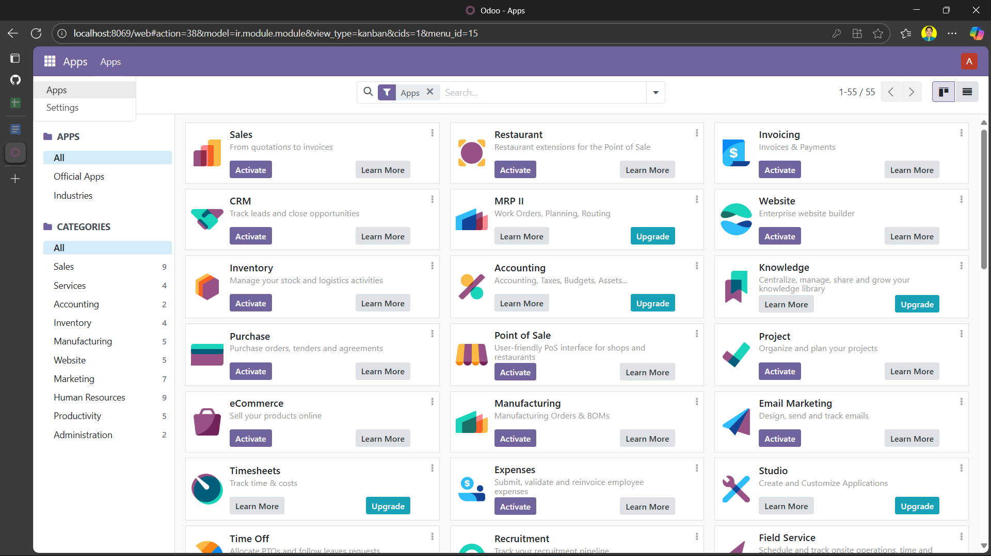
00

Proof of Created meta from clone (shallow) git hub

- SETTING UP:

